File 48_region_comsvc_veh_mean_age.csv
May 25, 2026
Definition of the Input File
VisionEval (https://visioneval.github.io/docs/model-inputs.html) explains that this input file contains average age of commercial service vehicles. This file contains one attribute:
- AveComSvcVehicleAge: average age of commercial service vehicles
For example, the data below suggest that the average age of commercial service vehicles in Virginia in 2024 is 8.7, while the value in 2045 is 11.5.
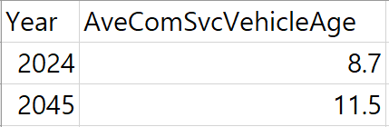
Possible Scenario
Changes to this file would likely be useful for analyzing the impacts of an aging or newer commercial service vehicle fleet within the model region. For example, increasing the average vehicle age may lead to higher fuel consumption, operating costs, and emissions, since older vehicles are generally less fuel-efficient compared with newer vehicles. The document Task 7.2 Simplified Scenario Development guide available at A Playbook for Simplified Approaches for Creating Scenarios in VisionEval does not mention this input file.
Method Used for Virginia
Based on the extrapolation method below, 2024 and 2045 values were estimated using several steps.
- Source 1: Age Distribution Projection Tool for MOVES5 (xltm), MOVES5 (Motor Vehicle Emission Simulator), EPA (U.S. Environmental Protection Agency)
  - URL: https://www.epa.gov/moves/tools-develop-or-convert-moves-inputs?utm_source=chatgpt.com#moves5-inputs
  - Location: epa.gov/moves–Tools for MOVES
  - Search Keyword: MOVES
  - Related Sheet: Not Applicable

- Source 2: Appendix A (MOVES Source Types by Regulatory Class), MOVES5 Technical Guidance: Using MOVES to Prepare Emission Inventories for State Implementation Plans and Transportation Conformity (pdf), EPA (U.S. Environmental Protection Agency)
  - URL: https://www.epa.gov/state-and-local-transportation/policy-and-technical-guidance-state-and-local-transportation#emission
  - Location: epa.gov/state-and-local-transportation–Policy and Technical Guidance for State and Local Transportation
  - Search Keyword: State and Local Transportation
  - Related Sheet: Not Applicable

- Year that the Data Reflect: 2024, 2045 (This tool was released in July 2025 and contains datasets covering the years 2012 through 2060.)
Note: To examine the proportion of each vehicle type, the relevant sheets must be unhidden.




- How the Data Were Processed
  - Vehicle Type Mapping: According to the MOVES5 Technical Guidance (see Source 2), SourceTypeIDs are categorized as follows. Since only commercial service light trucks are required for the input, SourceTypeID 32 was mapped for the analysis.
SourceTypeID | Vehicle Type (MOVES) | Vehicle Type (VisionEval)
21 | Passenger Car | Light Duty Vehicle
31 | Passenger Truck | Light Duty Vehicle
32 | Light Commercial Truck | Commercial Service Light Truck
52 | Single Unit Short-haul Truck | Heavy Truck
53 | Single Unit Long-haul Truck | Heavy Truck
61 | Combination Short-haul Truck | Heavy Truck
62 | Combination Long-haul Truck | Heavy Truck

  - Average Vehicle Age Calculation: The average vehicle age was calculated using a weighted average based on vehicle age and its corresponding proportion.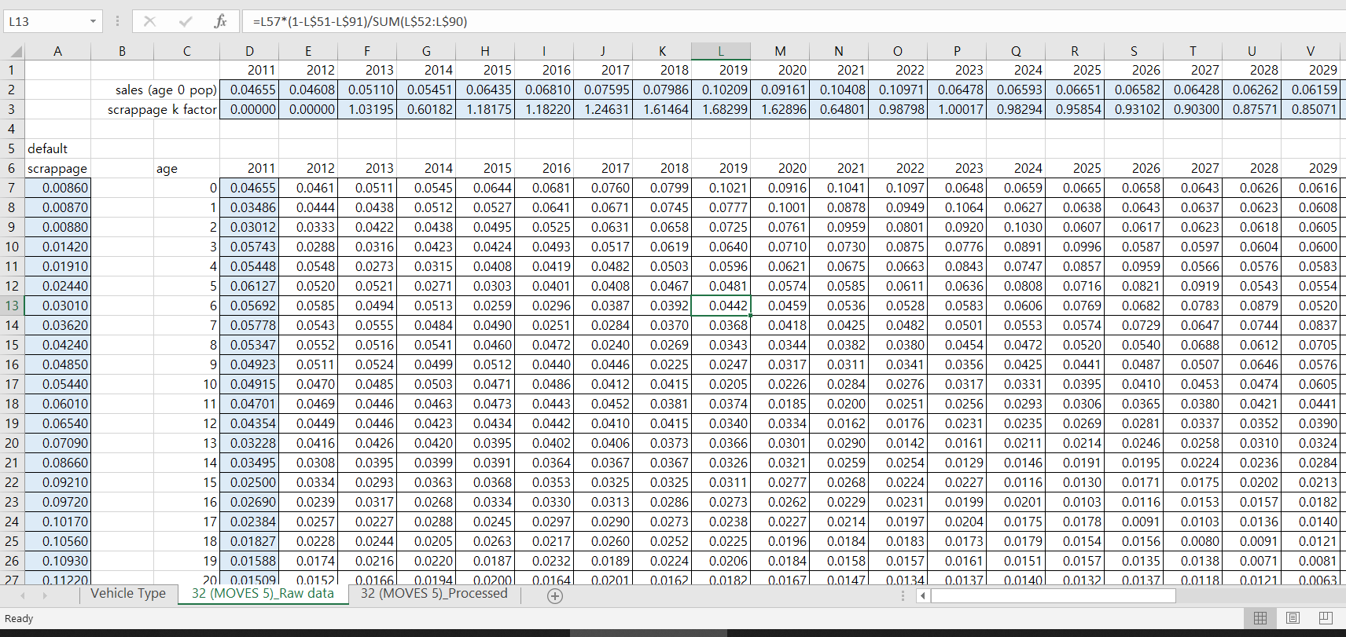
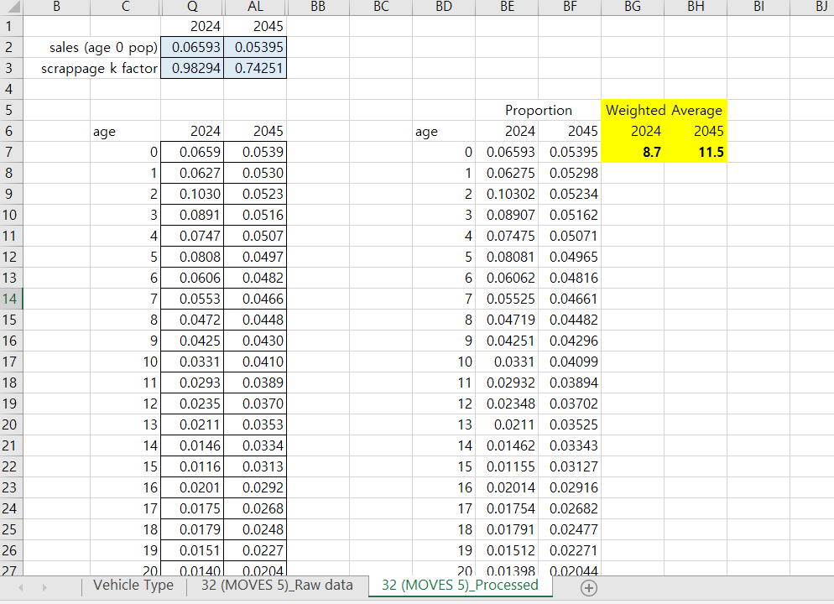
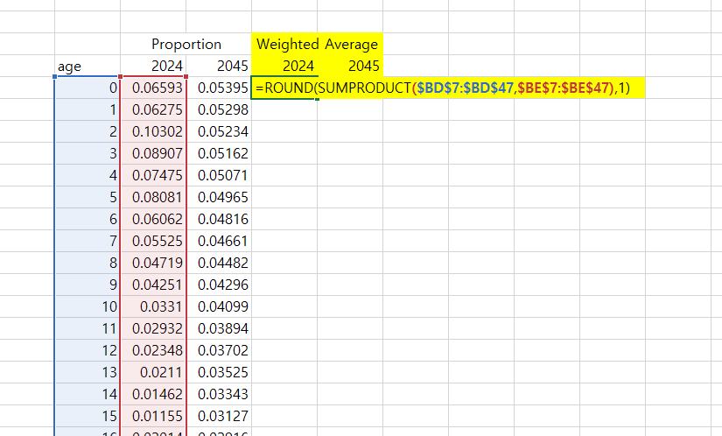

  - Final Result


